***E - Commerce Sales Analysis***

**Dataset**  = Kaggle (<https://www.kaggle.com/datasets/mayukhbaruah/super-store-usa>).

**Libraries Used :**

1. Pandas

2. Numpy

3. Matplotlib

4. Seaborn

***Feature of Dataset:***

1 . Row ID

2. Order Priority

3. Discount

4. Unit Price

5. Shipping Cost

6. Customer ID

7. Customer Name

8. Ship Mode

9. Customer Segment

10. Product Category

11. Product Sub-Category

12. Product Container

13. Product Name

4. Product Base Margin

15. Region

16. State or Province

17. City

18. Postal Code

19. Order Date

20. Ship Date

21. Profit

22. Quantity ordered new

23. Sales

24. Order ID

***Contents:***

1. Import the required libraries.

2. Import and reading dataset.

3. Data- Cleaning

4. Data- Mining.

4. Data- Visualization

***Data Variable in the dataset :***

Data

***Conclusion of Data Analysis:***

1. **Order Priority** There Is define most of the customers satisfy with product. **Maximum** number of customers have **High** Priority. But Most of the customers have low Priority as well.

Some are **Not Specified**, and **Critical. Medium Order priority** is in Middle.

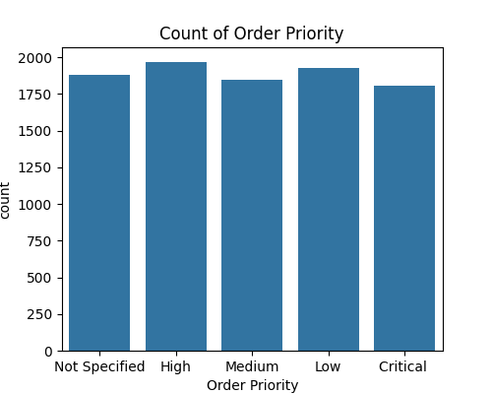

2**.** Highest **Ship Mode** From Regular Air which is 74% , Second is **Delivery truck** which is 13% And last one **Express air**.

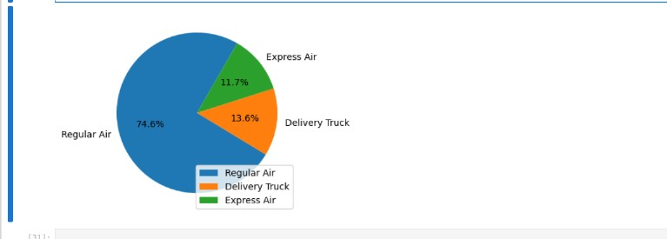

3. Product Category Have Three Product Which is Office Supplies, Technology, Furniture.

The graph shown , Maximum number is **Office Supplies** By **Regular Air** and Less Number of supplies by **Delivery truck**.

Also the Maximum **furniture** products Shipped **by Delivery truck** , Less Number Of Products shipped by **Express air**.

**Highest** **Technology Product** shipped by **Regular Air**. And least number of product shipped by **Delivery truck and Express Air.**

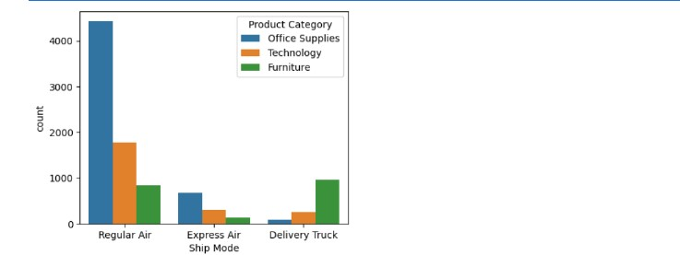

4. There is different type of Customer Segment. **Corporate** Has More customers , then there is **Home Office** And minimum customers have **Small Business, Consumer**.

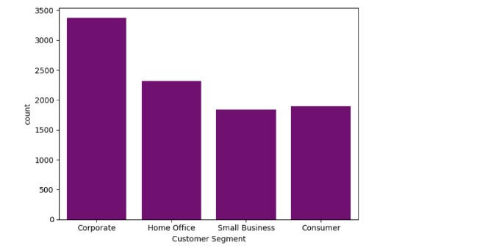

5. The Most Popular Product **Office Supplies**, after That **Technology** and **Furniture**.

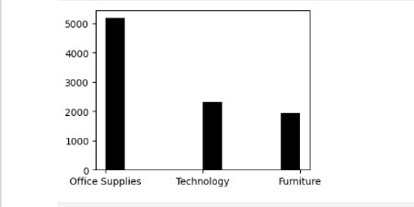

6. **Office Supplies** have also many categories Most Demanded Product is **Paper** and lowest **Rubber Bands.**

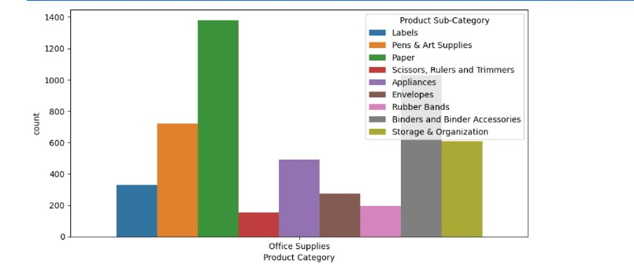

7. In **Technology ,** highest shipped product **Telephones and Communication** and **Copiers and** **fax** not more demanded products.

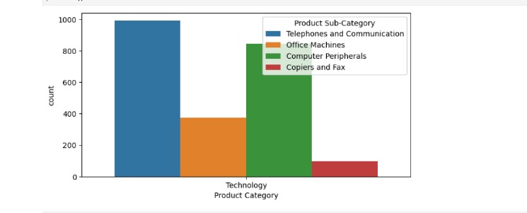

8. There **is furniture** Categories , and we can see that **Office Furnishings** highest shipped and lowest **Bookcases** , and **Tables** , **chairs & Chairmats** also demanded products.

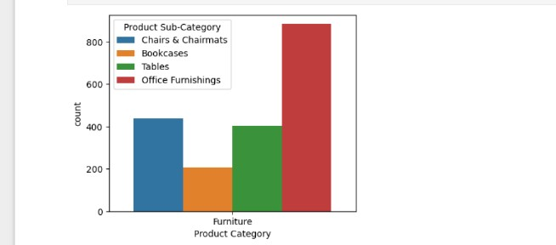

9. When we talk about Profit so we can also see that **Technology‘s products** have gained the most profit , **Office supplies have** also minimum profit but **furniture** has low profit.

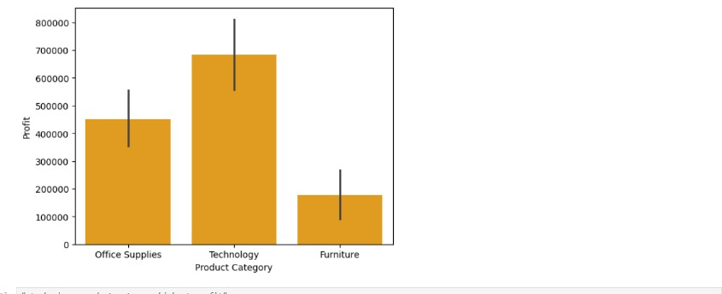

10. Now we can see from which states maximums customers have visited.

These are the **Top 5 State** where Our product on demand.



11. These are the **lowest State** where the products not so much demanded.



12**.** If We calculate  **Product Base Margin ,** then this graph define we have more margin in **furniture Supplies**, and **Office supplies** have not too much margin.(But Its very demanded).

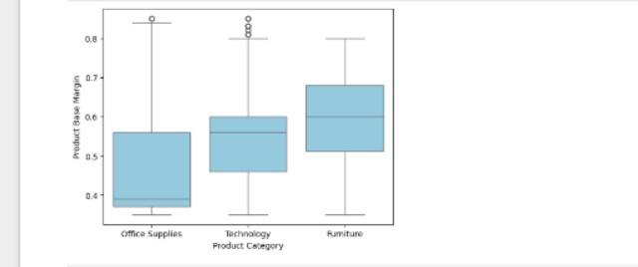

13. **Quantity ordered new , District of Columbia, Massachusetts, New York,** These are the State which have new Maximum Number of quantity ordered.

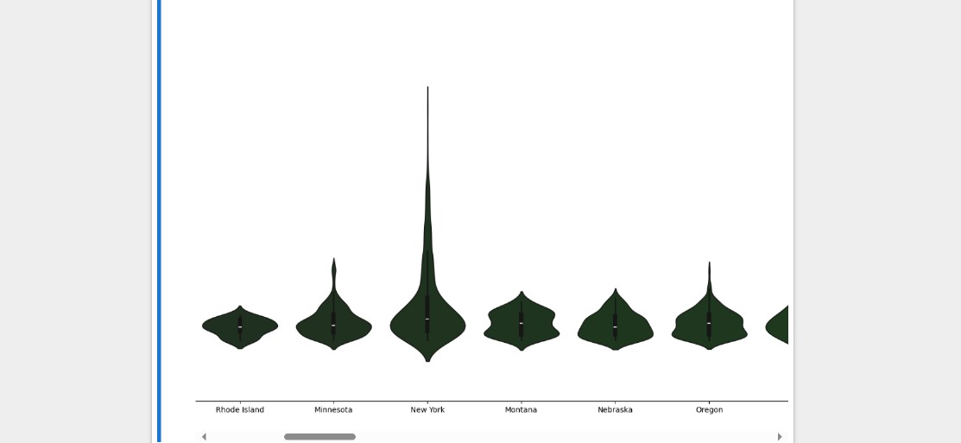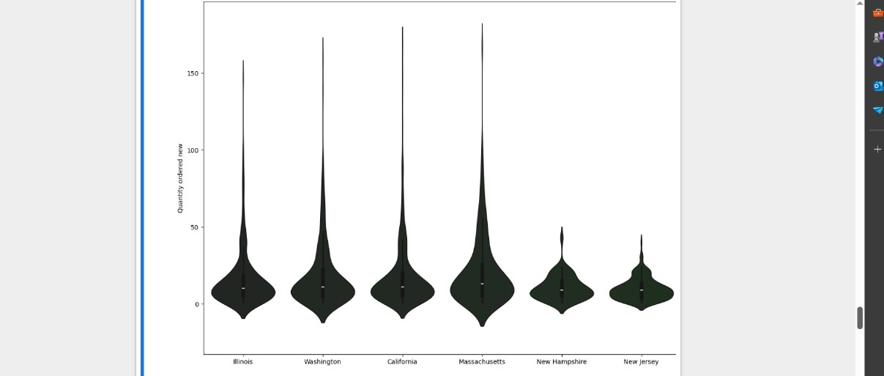  
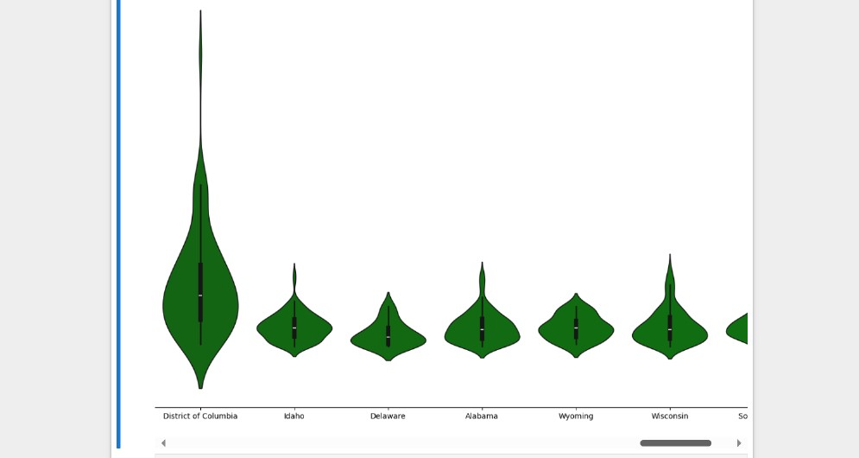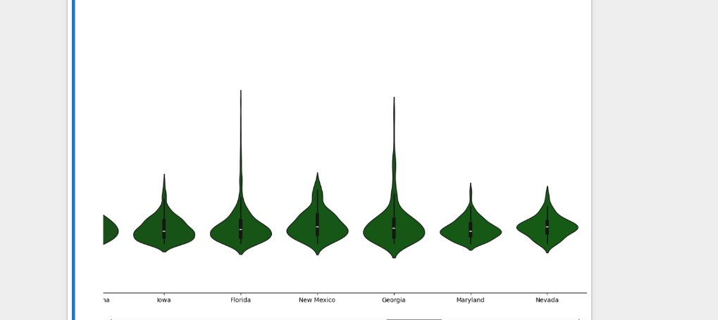

14.  **Technology** Have More Unit price and **Office Supplies** unit price is not too high.

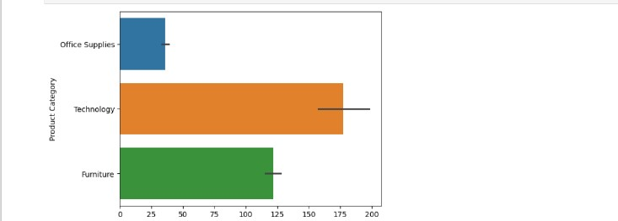

15. In This graph define that highest sales price product is **Furniture.**  **technology** have also a maximum sales **but office supplies** sales price is low.

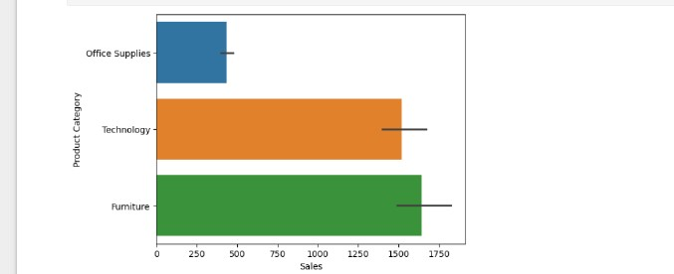

16. It is **State or Province** base graphs which define every state role is every number of columns.

